R and Python

## R

x = sample(1:100, size = 1000, replace = TRUE)  
y = rnorm(1000, mean = 40, sd = 2)  
  
plot(x, y)

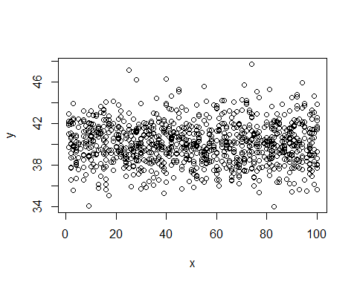

## python

import numpy as np  
a = np.arange(15).reshape(3, 5)  
a

array([[ 0, 1, 2, 3, 4],  
 [ 5, 6, 7, 8, 9],  
 [10, 11, 12, 13, 14]])

import matplotlib.pyplot as plt  
  
fig = plt.figure()  
x = np.arange(10)  
y = 2.5 * np.sin(x / 20 * np.pi)  
yerr = np.linspace(0.05, 0.2, 10)  
  
plt.errorbar(x, y + 3, yerr=yerr, label='both limits (default)')  
plt.errorbar(x, y + 2, yerr=yerr, uplims=True, label='uplims=True')  
plt.errorbar(x, y + 1, yerr=yerr, uplims=True, lolims=True,  
 label='uplims=True, lolims=True')  
  
upperlimits = [True, False] * 5  
lowerlimits = [False, True] * 5  
plt.errorbar(x, y, yerr=yerr, uplims=upperlimits, lolims=lowerlimits,  
 label='subsets of uplims and lolims')  
  
plt.legend(loc='lower right')  
plt.show(fig)

